**WebLogic Home Paths**

1. **$WLS_HOME:** ps -eaf|grep -i <AdminServer/Managed Server>

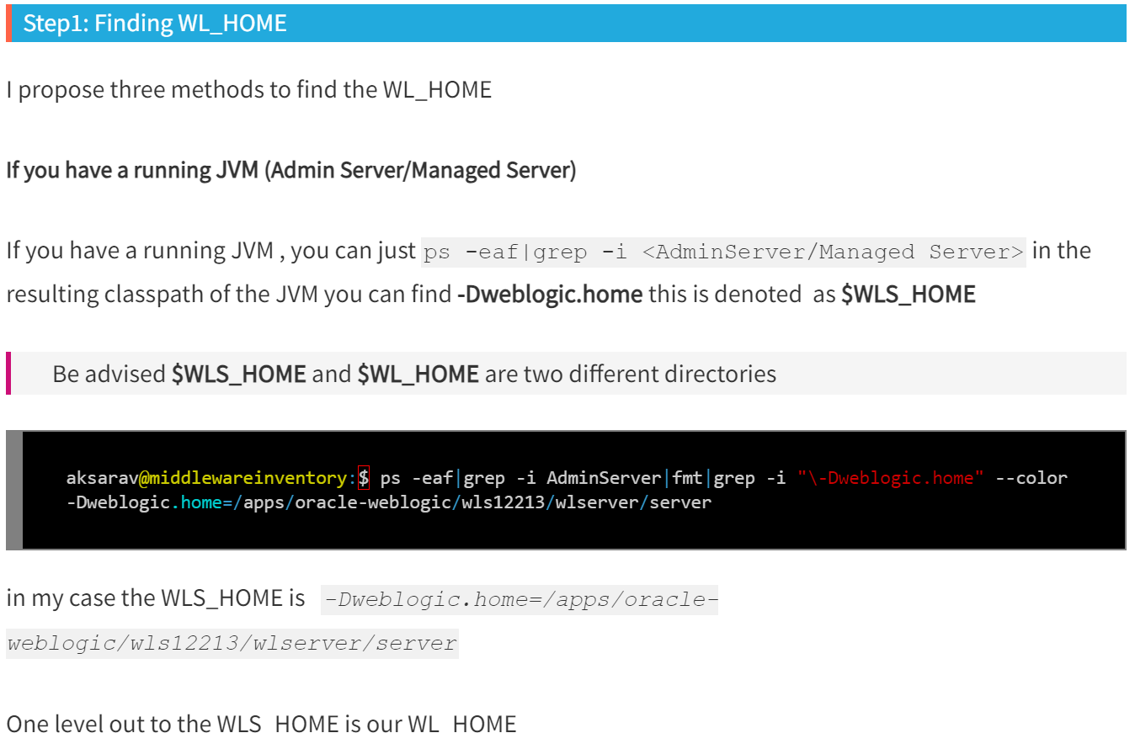

1. **Set Domain Environment:**

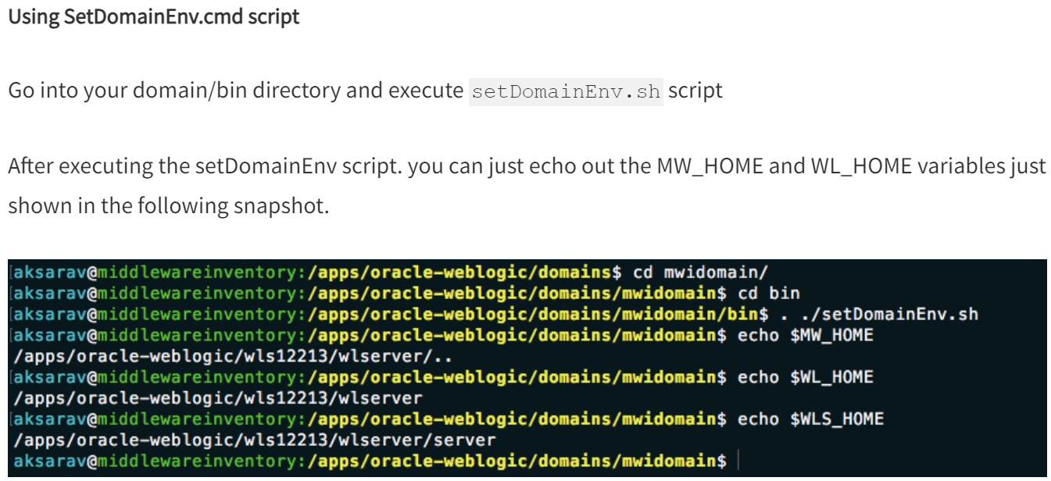

1. **Find MW_HOME:**

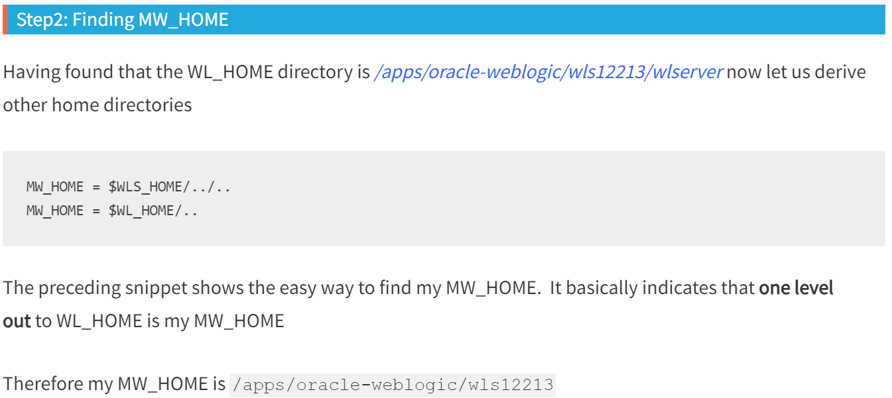

1. **Find Oracle_Common_Home:**

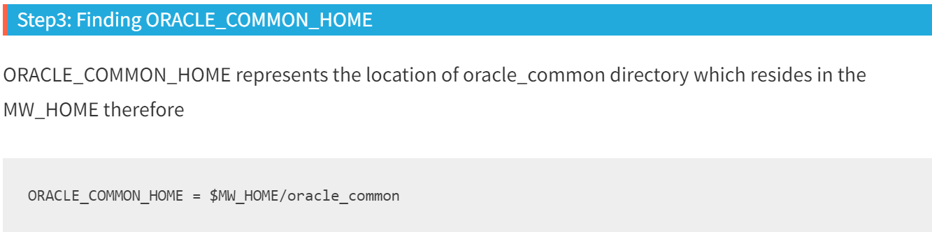

1. **Find Oracle_Home:**

